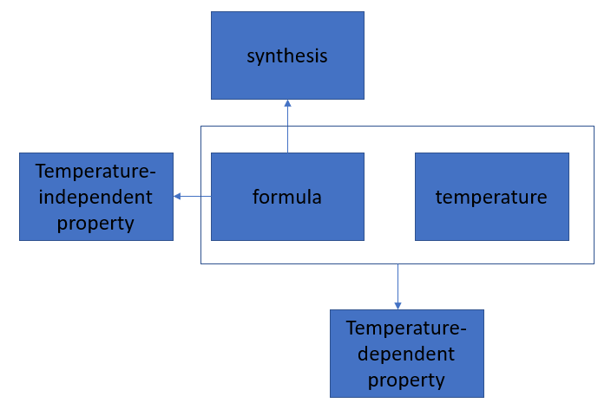

\*\*correct unit can be found in JSON file

A -> B

* What is temperature-independent property of formula

(temperature-independent property includes:

form

Average atomic mass (g/mol)

Scarcity (wt fraction/abundance)

HHIP (Herfindahl−Hirschman Index for elemental production)

HHIR (Herfindahl−Hirschman Index for elemental reserves)

Unit cell volume (â„«Â³)

Average atomic volume (â„«Â³)

Atoms per unit cell

)

* How can formula be synthesized -> synthesis

A+B -> C

* What is temperature-dependent property of formula in temperature

(temperature-independent property includes:

Electrical resistivity (Î©cm)

Seebeck coefficient (Î¼CV/K)

ZT (thermoelectric figure of merit)

Thermal conductivity (W/mK)

Electrical conductivity (Î©â»Â¹ cmâ»Â¹)

Power Factor (W/(KÂ²m))

SÂ² (Î¼V/K)Â²

Electronic fraction of thermal conductivity (Ï°â‚‘/Ï°)

)

Unable to answer

* What is temperature-dependent property of formula